**Name: Mahin Prakash**

**Video Game Dataset Insights**

1. **Top 10 popular platforms**

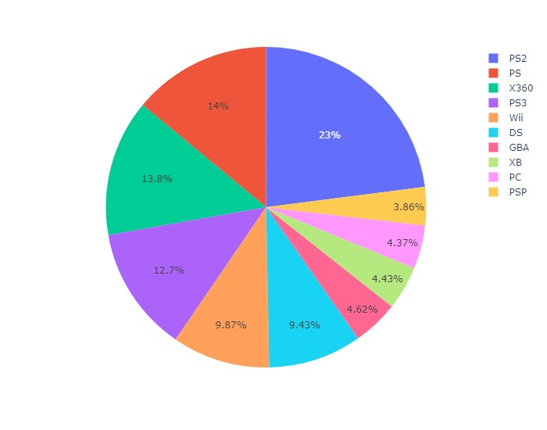

1. **Genres which have received more than 90% rating or review**

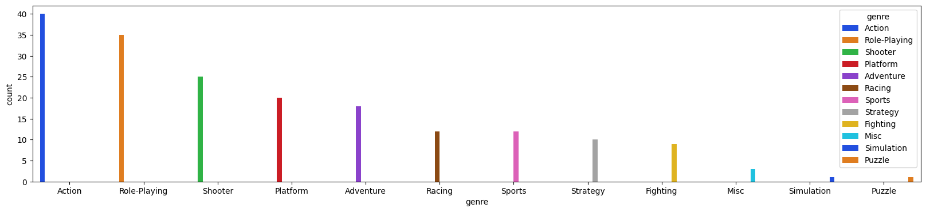

1. **Title which has received the highest sales Globally**

“Wii Sports”

1. **Title which has received the highest review rating**

'The Legend of Zelda: Ocarina of Time'

1. **Years in which more than 100 games were launched**

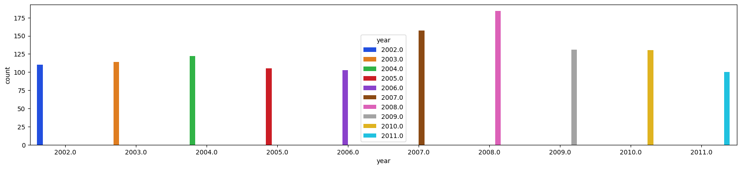

1. **Sales by Genre**

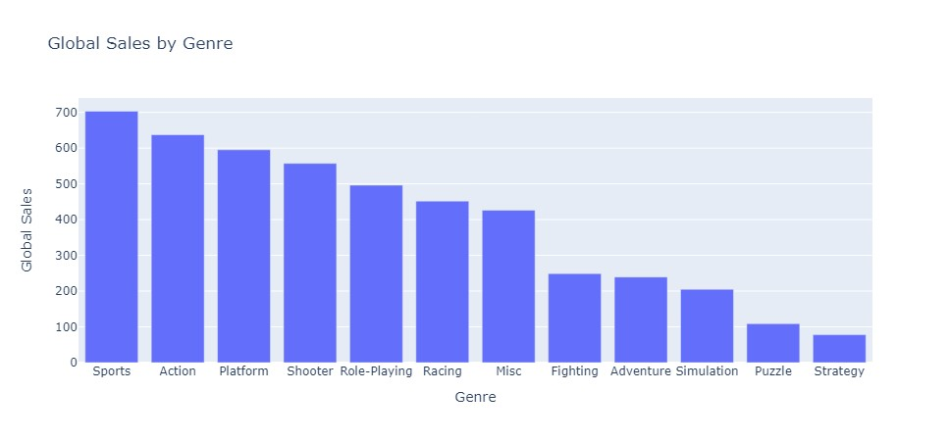

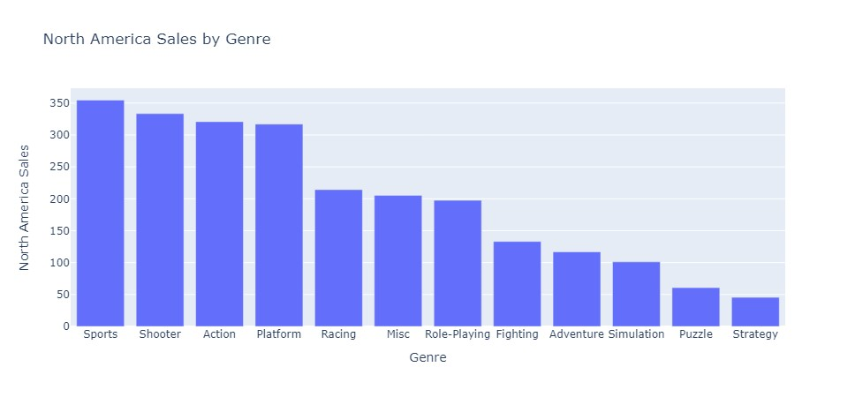

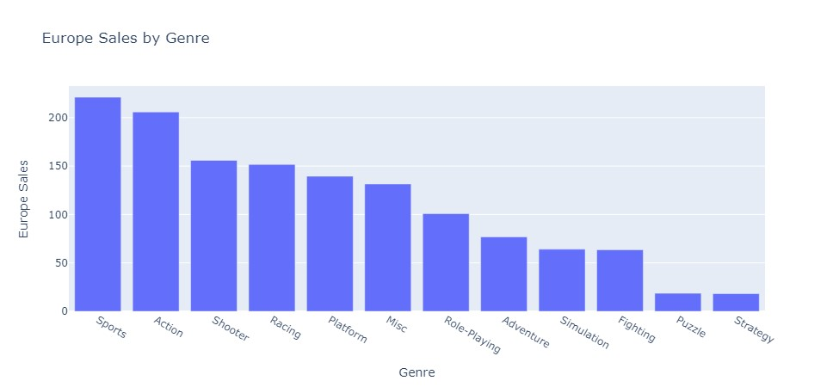

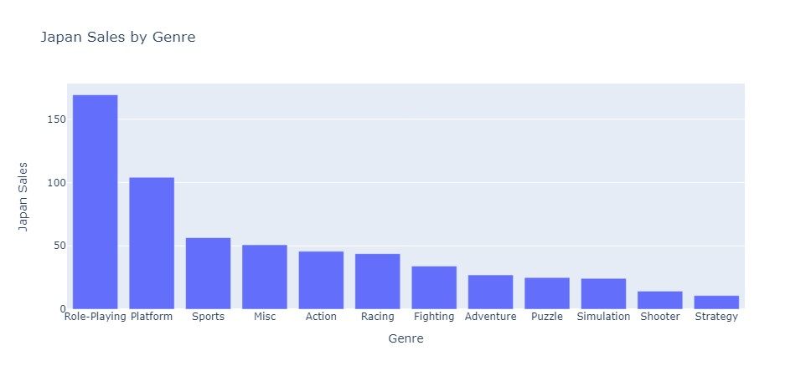

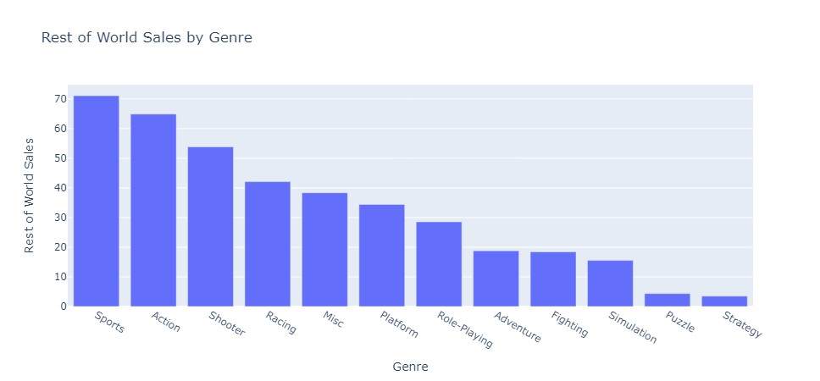

**7)Global Sales by Genre over the Years**

